TAXABLE INCOME
(1) Salaries & Self-Emp Income 65,000 85,100 88,152 99,786 102,727
Salary - Client 60,000 65,000 66,950 78,000 80,340
Salary - Second Client 0 15,000 16,000 16,480 16,974
Self-Employment - Second 5,000 5,100 5,202 5,306 5,412

(2) Other Ord Income + Soc Sec 0 0 0 0 0

(3) Interest & Dividends 13,651 115,664 16,478 16,862 17,784
D)ABC Mutual Fund 2,751 3,041 3,361 3,715 4,107
D)Common Stock 1,000 1,050 1,103 1,158 1,216
I)Cert. of Deposit 1,538 1,632 1,732 1,839 1,952
I)Corporate Bond 850 850 850 850 850
I)Money Market Fund 812 823 833 843 854
I)Note Carryback on Lot 1,200 102,461 0 0 0
I)Savings Account 5,500 5,808 6,132 6,475 6,837
I)Interest: Surplus Cash 0 0 2,466 1,981 1,968

(4) Gross Capital Gains 0 75,000 0 0 0
L)Note Carryback on Lot 0 75,000 0 0 0

(5) Passive Income 0 0 2,438 4,596 5,110
Rental Property 0 0 2,438 4,596 5,110

(6) Gross Income 78,651 275,764 107,068 121,244 125,621

INCOME TAXES

(7) Adjustments To Income 10,353 10,360 10,368 10,375 10,382
1/2 Self-Emp. Soc. Sec. 353 360 368 375 382
IRA - John 5,000 5,000 5,000 5,000 5,000
IRA - Mary 5,000 5,000 5,000 5,000 5,000

(8) Usable Ordinary Losses 0 0 0 0 0

(9) Usable Capital Losses 0 0 0 0 0

(10) Usable Passive Losses 1,854 0 1,425 0 0
Allowed Suspended Losses 0 0 1,425 0 0
Rental Property 1,854 1,425 0 0 0
Suspended Losses 0 -1,425 0 0 0

(11) Adjusted Gross Income 66,443 265,403 95,275 110,869 115,238

(12) Usable Deductions 17,517 34,663 19,195 19,911 19,897
Deduct Form-Charitable 400 400 400 400 400
Personal Residence 1,600 1,632 1,665 1,698 1,732
Porsche 100 95 90 86 81
VA 1st Mtge 13,987 13,738 13,459 13,145 12,794
California State Tax 1,429 18,798 3,582 4,582 4,889

(13) California Tax Estimate 1,429 18,798 3,582 4,582 4,889

(14) Exemption Amount 21,900 22,557 23,234 23,931 24,649

(15) Form 1040 Taxable Income 27,027 208,183 52,846 67,027 70,693
State Taxable Income 50,356 245,746 79,662 95,540 100,231

(16) Tax Credits 1,676 0 118 0 0
Child Credit 4,000 0 2,000 1,924 1,158
Excess Credit -2,324 0 -1,882 -1,924 -1,158

(17) Federal Tax 980 50,306 7,809 11,519 12,306
Table Tax 2,656 36,512 7,927 10,054 10,604
AMT Tax 980 50,306 7,809 11,519 12,306

(18) Method table alt min table alt min alt min

(19) Combined Tax Bracket 20.10 32.88 21.80 32.88 32.88

(20) Addl. Pref. Before AMT 6,448 0 455 0 0

CASH FLOW

(21) Total Cash Flow 75,400 297,178 100,674 112,284 115,695
Common Stock 1,000 1,050 1,103 1,158 1,216
Corporate Bond 850 850 850 850 850
Lines 1-8: Cash Flow Form 65,000 85,100 88,152 99,786 102,727
Note Carryback on Lot 1,200 202,461 0 0 0
Rental Property 7,350 7,718 8,103 8,509 8,934
Interest on Surplus Cash 0 0 2,466 1,981 1,968

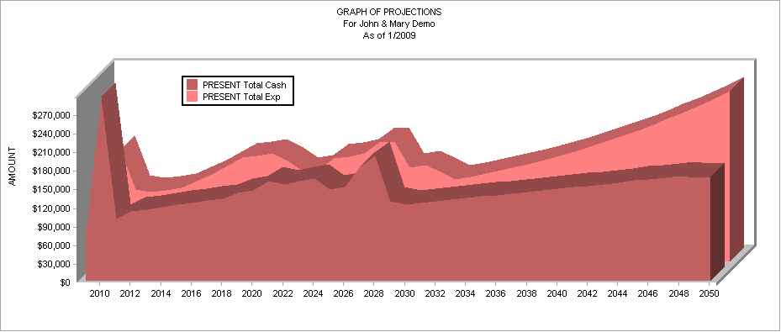

(22) Living Expenses 30,150 31,356 32,610 33,915 35,271

(23) Extraordinary Liv. Expense 0 0 0 0 0
From Tax Form 0 0 0 0 0

(24) Federal & State Taxes 2,409 69,105 11,390 16,101 17,195
Federal 980 50,306 7,809 11,519 12,306
State 1,429 18,798 3,582 4,582 4,889

(25) Social Security Taxes 5,296 6,841 7,081 7,977 8,209

(26) Loan, Property & Other Exp 62,318 62,619 55,637 44,585 44,919
Auto Loan 17,170 17,170 0 0 0
Disability Insurance 400 412 424 437 450
Jewelry 250 258 265 273 281
Jones 2nd on Rental 1,500 1,500 11,375 0 0
Liability Insurance 12,000 12,000 12,000 12,000 12,000
Medical Insurance 750 750 750 750 750
Personal Residence 3,540 3,642 3,748 3,856 3,969
Porsche 3,600 3,715 3,834 3,958 4,087
Rental 1st Mortgage 3,635 3,635 3,635 3,635 3,635
Rental Property 1,680 1,727 1,776 1,827 1,879
Term Life 600 618 637 656 675
VA 1st Mtge 16,043 16,043 16,043 16,043 16,043
Whole Life Policy 1,150 1,150 1,150 1,150 1,150

(27) Investments 10,135 10,135 10,135 10,135 10,135
ABC Mutual Fund 10 10 10 10 10
Common Stock 25 25 25 25 25
Savings Account 100 100 100 100 100
IRA - John 5,000 5,000 5,000 5,000 5,000
IRA - Mary 5,000 5,000 5,000 5,000 5,000

(28) Surplus Cash -34,908 117,123 -16,178 -430 -35

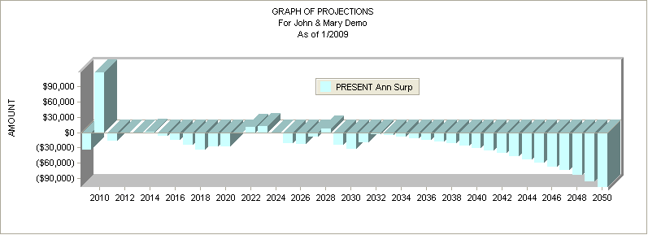

LIQUIDITY

(29) Accumulated Surplus Cash -34,908 82,214 66,036 65,606 65,571

(30) Cash Assets 172,404 179,134 186,200 193,618 201,409

(31) Total Cash Assets 137,496 261,348 252,236 259,225 266,981

RETIREMENT PLANS

(32) Plan Contributions 10,000 10,000 10,000 10,000 10,000
(see Investments)

(33) Plan Projected Balance 95,832 114,552 134,793 156,692 180,401
Fixed Annuity 11,000 12,100 13,310 14,641 16,105
IRA - John 25,200 31,460 38,033 44,935 52,181
IRA - Mary 17,172 23,546 30,429 37,864 45,893
Non-Qual. Vari. Annuity 9,300 10,801 12,531 14,526 16,822
Qual. Variable Annuity 22,160 24,545 27,179 30,086 33,294
Qualified Fixed Annuity 11,000 12,100 13,310 14,641 16,105

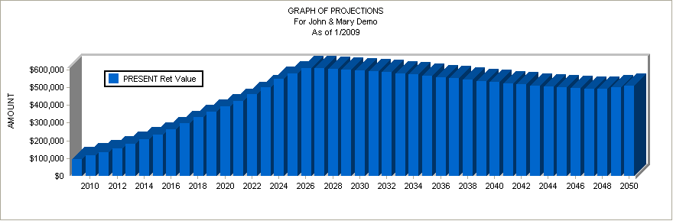

NET WORTH

(34) Apparent Net Worth 1,254,306 1,279,619 1,359,142 1,450,729 1,549,524
ABC Mutual Fund 120,104 132,763 146,755 162,221 179,316
Auto Loan -16,284 0 0 0 0
Cert. of Deposit 26,538 28,170 29,902 31,741 33,693
Checking Account 1,000 1,000 1,000 1,000 1,000
Common Stock 289,087 306,457 324,870 344,387 365,075
Corporate Bond 8,500 8,500 8,500 8,500 8,500
Fixed Annuity 11,000 12,100 13,310 14,641 16,105
IBM 51,000 52,020 53,060 54,122 55,204
IRA - John 25,200 31,460 38,033 44,935 52,181
IRA - Mary 17,172 23,546 30,429 37,864 45,893
Jewelry 41,600 43,264 44,995 46,794 48,666
Jones 2nd on Rental -10,000 -10,000 0 0 0
Mary's Side Business 22,980 23,669 24,379 25,111 25,864
Money Market Fund 65,812 66,635 67,468 68,311 69,165
Non-Qual. Vari. Annuity 9,300 10,801 12,531 14,526 16,822
Note Carryback on Lot 187,937 0 0 0 0
Personal Residence 236,250 248,063 260,466 273,489 287,163
Porsche 97,000 94,090 91,267 88,529 85,873
Qual. Variable Annuity 22,160 24,545 27,179 30,086 33,294
Qualified Fixed Annuity 11,000 12,100 13,310 14,641 16,105
Rental 1st Mortgage -27,261 -25,961 -24,542 -22,993 -21,304
Rental Property 102,375 107,494 112,868 118,512 124,437
Savings Account 105,592 111,499 117,732 124,307 131,244
VA 1st Mtge -120,497 -118,192 -115,609 -112,711 -109,463
Whole Life Policy 11,650 13,382 15,202 17,112 19,117
Accumulated Surplus Cash -34,908 82,214 66,036 65,606 65,571

(35) 3.00% Inflation Adjusted 1,254,306 1,242,349 1,281,122 1,327,623 1,376,732

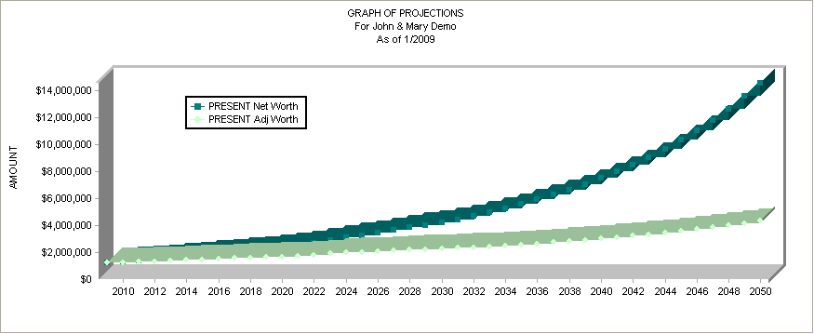

The Current Financial Projection Report is actually six reports presented as one. These reports are: a taxable income summary, an income tax summary, a cash flow report, a liquidity statement, a retirement plan summary and an annual net worth status report.
We can also prepare a Proposed Financial Projection Report which is identical to the first, with the exception that it shows how things are expected to evolve assuming you make all the recommended changes we propose.
The report begins in 2009 and can run to 2049, John’s life expectancy. All anticipated cash income and expenses are included over this time frame including retirement income from all sources first beginning in 2025 when John is age 65. In one sense, this approach can be thought of as a total simulation model. All of the various elements of your financial affairs have been integrated into a comprehensive annual overview report permitting us to quickly spot any problems or trends.
The first six lines of the report pertain to your taxable income for each year. In 2009 your taxable gross income is scheduled to be $78,651.
This includes earned income for John of $60,000 and earned income for Mary of $5,000.
Lines 7 through 20 of the report relate to the computation of your federal and state income taxes. In 2009 we show you having $10,353 of adjustments to your income. Adjustments are such things as IRA’s and certain other pension plan contributions.
We are also showing $1,854 of usable passive losses on line 10. These write-offs are being generated from investments you already own.
After making adjustments for any passive losses, capital losses, itemized deductions, including state income tax payments, and your exemptions, we arrive at your taxable income for 2009 of $31,266.
You’ll notice that your federal and state tax estimate is $3,852 using the table method and that you’re in the 20% combined tax bracket.
In 2009 you will receive $215,400 in total cash flow.
If we subtract $30,150 of living expenses, $3,852 of taxes, $5,296 of FICA withholding, $179,735 of loan and property expenses, and $10,135 of investments, you will end the year with a surplus of $-13,769. We call this Annual Surplus Cash. Any balance of annual free cash is automatically assumed to be invested in a money market account at 3.00%. This balance is carried forward each year in the Accumulated Surplus Cash fund as shown on line 29.
Lines 32 and 33 of the report show the total amount of money going into your retirement plans, and the total value of the plans at the end of each year.
This year there will be a total of $10,000 contributed to your retirement plans. When adding this figure to your current balance, plus this year’s expected investment earnings, we find that you’re expected to have a total of $95,832 in your retirement plans by the end of 2009.
The final two lines of the report project your net worth from this year to 2049. Line 34 illustrates what your net worth is projected to be without regard to the effect inflation will have on purchasing power. Line 35 shows what those dollars are actually going to be worth assuming we experience a 3.00% average inflation rate.

TAXABLE INCOME
(1) Salaries & Self-Emp Income 65,000 85,100 88,152 99,786 102,727
(2) Other Ord Income + Soc Sec 0 0 0 0 0
(3) Interest & Dividends 13,651 115,601 17,088 17,312 18,063
(4) Gross Capital Gains 0 75,000 0 0 0
(5) Passive Income 0 0 2,438 4,596 5,110
(6) Gross Income 78,651 275,701 107,678 121,694 125,900

INCOME TAXES
(7) Adjustments To Income 10,353 10,360 10,368 10,375 10,382
(8) Usable Ordinary Losses 0 0 0 0 0
(9) Usable Capital Losses 0 0 0 0 0
(10) Usable Passive Losses 1,854 0 1,425 0 0
(11) Adjusted Gross Income 66,443 265,341 95,885 111,319 115,517
(12) Usable Deductions 13,278 30,370 14,617 15,803 15,933
(13) California Tax Estimate 1,700 19,285 3,615 4,891 5,118
(14) Exemption Amount 21,900 22,557 23,234 23,931 24,649
(15) Form 1040 Taxable Income 31,266 212,414 58,035 71,585 74,936
(16) Tax Credits 1,140 0 0 0 0
(17) Federal Tax 2,153 51,840 9,166 12,785 13,469
(18) Method table alt min alt min alt min alt min
(19) Combined Tax Bracket 20.10 32.88 32.88 32.88 32.88
(20) Addl. Pref. Before AMT 4,384 0 0 0 0

CASH FLOW
(21) Total Cash Flow 215,400 307,178 101,410 112,861 116,103
(22) Living Expenses 30,150 31,356 32,610 33,915 35,271
(23) Extraordinary Liv. Expense 0 0 0 0 0
(24) Federal & State Taxes 3,852 71,125 12,781 17,676 18,586
(25) Social Security Taxes 5,296 6,841 7,081 7,977 8,209
(26) Loan, Property & Other Exp 179,735 57,195 50,213 39,161 39,495
(27) Investments 10,135 20,154 20,179 20,204 10,210
(28) Surplus Cash -13,769 120,508 -21,453 -6,071 4,331

LIQUIDITY
(29) Accumulated Surplus Cash -13,769 106,738 85,285 79,214 83,545
(30) Cash Assets 172,404 169,072 176,011 183,303 190,965
(31) Total Cash Assets 158,635 275,810 261,297 262,517 274,510

RETIREMENT PLANS
(32) Plan Contributions 10,000 10,000 10,000 10,000 10,000
(33) Plan Projected Balance 95,832 114,552 134,793 156,692 180,401

NET WORTH
(34) Apparent Net Worth 1,257,373 1,286,070 1,371,715 1,470,735 1,578,194
(35) 3.00% Inflation Adjusted 1,257,373 1,248,612 1,292,973 1,345,931 1,402,205

